**Error! Filename not specified.**

Job Title: Volunteer Water Polo Senior Assistant Coach – GB & England Squad (2 positions available, 1 x male, 1 x female teams).

**Context:** Senior squads preparing for World Aquatics (WA) and European Aquatics (EA) events throughout 2024 – 2026, culminating in EA European Championships, 2026.

Department: Water Polo  
Reporting to: Head Coach and Water Polo Programme Lead  
Direct Reports: N/A  
Location: Home Based with UK and International Travel. The location of training, camps and/or competitions will vary. Domestic training often occurs in the North West, Midlands or South East.

**Essential**

* Be able to develop an individual’s potential and technical knowledge of WP
* Have an appreciation of sports science, medicine and performance lifestyle disciplines and how they along with coaching, create a progressive talent environment
* Knowledge of safeguarding and an understanding and commitment to safeguarding (Wave Power), inclusion, and equal opportunities
* An understanding of individual responsibility in complying with Health and Safety
* Have a positive approach to being part of a team and be willing to follow direction from the Head Coach
* Passionate about an open and fair approach to talent development
* Understand the demands and challenges of managing a team both domestically and internationally, in training and competition
* Coaching experience within a national and/or international water polo programme
* Ability to communicate effectively orally and in writing to maintain effective relationships with key stakeholders
* Hold a current Swim England DBS or be willing to undertake an enhanced DBS check

**Desirable**

* Insight into or experience within, a national talent programme or equivalent.

**Skills and experience required**

**Job Purpose:**

The Assistant Coach role is primarily as a support to the Head Coach as well as a developmental role for those aspiring to be future head coaches. You will support the training and coaching of senior players to improve individual and team performances. Support the delivery of a periodised plan. Ensure that each athlete is empowered and his or her Individual Development Plan (IDP) is delivered.

* Build a strong relationship with the Senior players and potential players
* Create a strong relationship with the Squad Team Manager, Head Coach, GB Junior squad coaches and any specialist support staff.
* Work under the direction of the Head Coach, and other specialist professionals.
* To promote strong squad values including respect, punctuality, hard work,
* To support Swim England player education initiative e.g. nutrition, strength and conditioning, anti-doping and Sports Psychology etc.
* To contribute to a healthy environment for aspiring elite athletes.
* To contribute towards a long term performance plan with the Water Polo Programme Lead to deliver the aim of becoming credible in Europe.
* To support the delivery of the Swim England and British Swimming Senior Squad’s performance plan and calendar for the appointed squad.
* Identify, monitor and communicate programme-related progress with the Head Coach.
* To be a role model and ambassador on behalf of Swim England, building positive healthy relationships.

**Key responsibilities**

**Values:**

Quality

Purpose

Togetherness

Fun

Resourceful



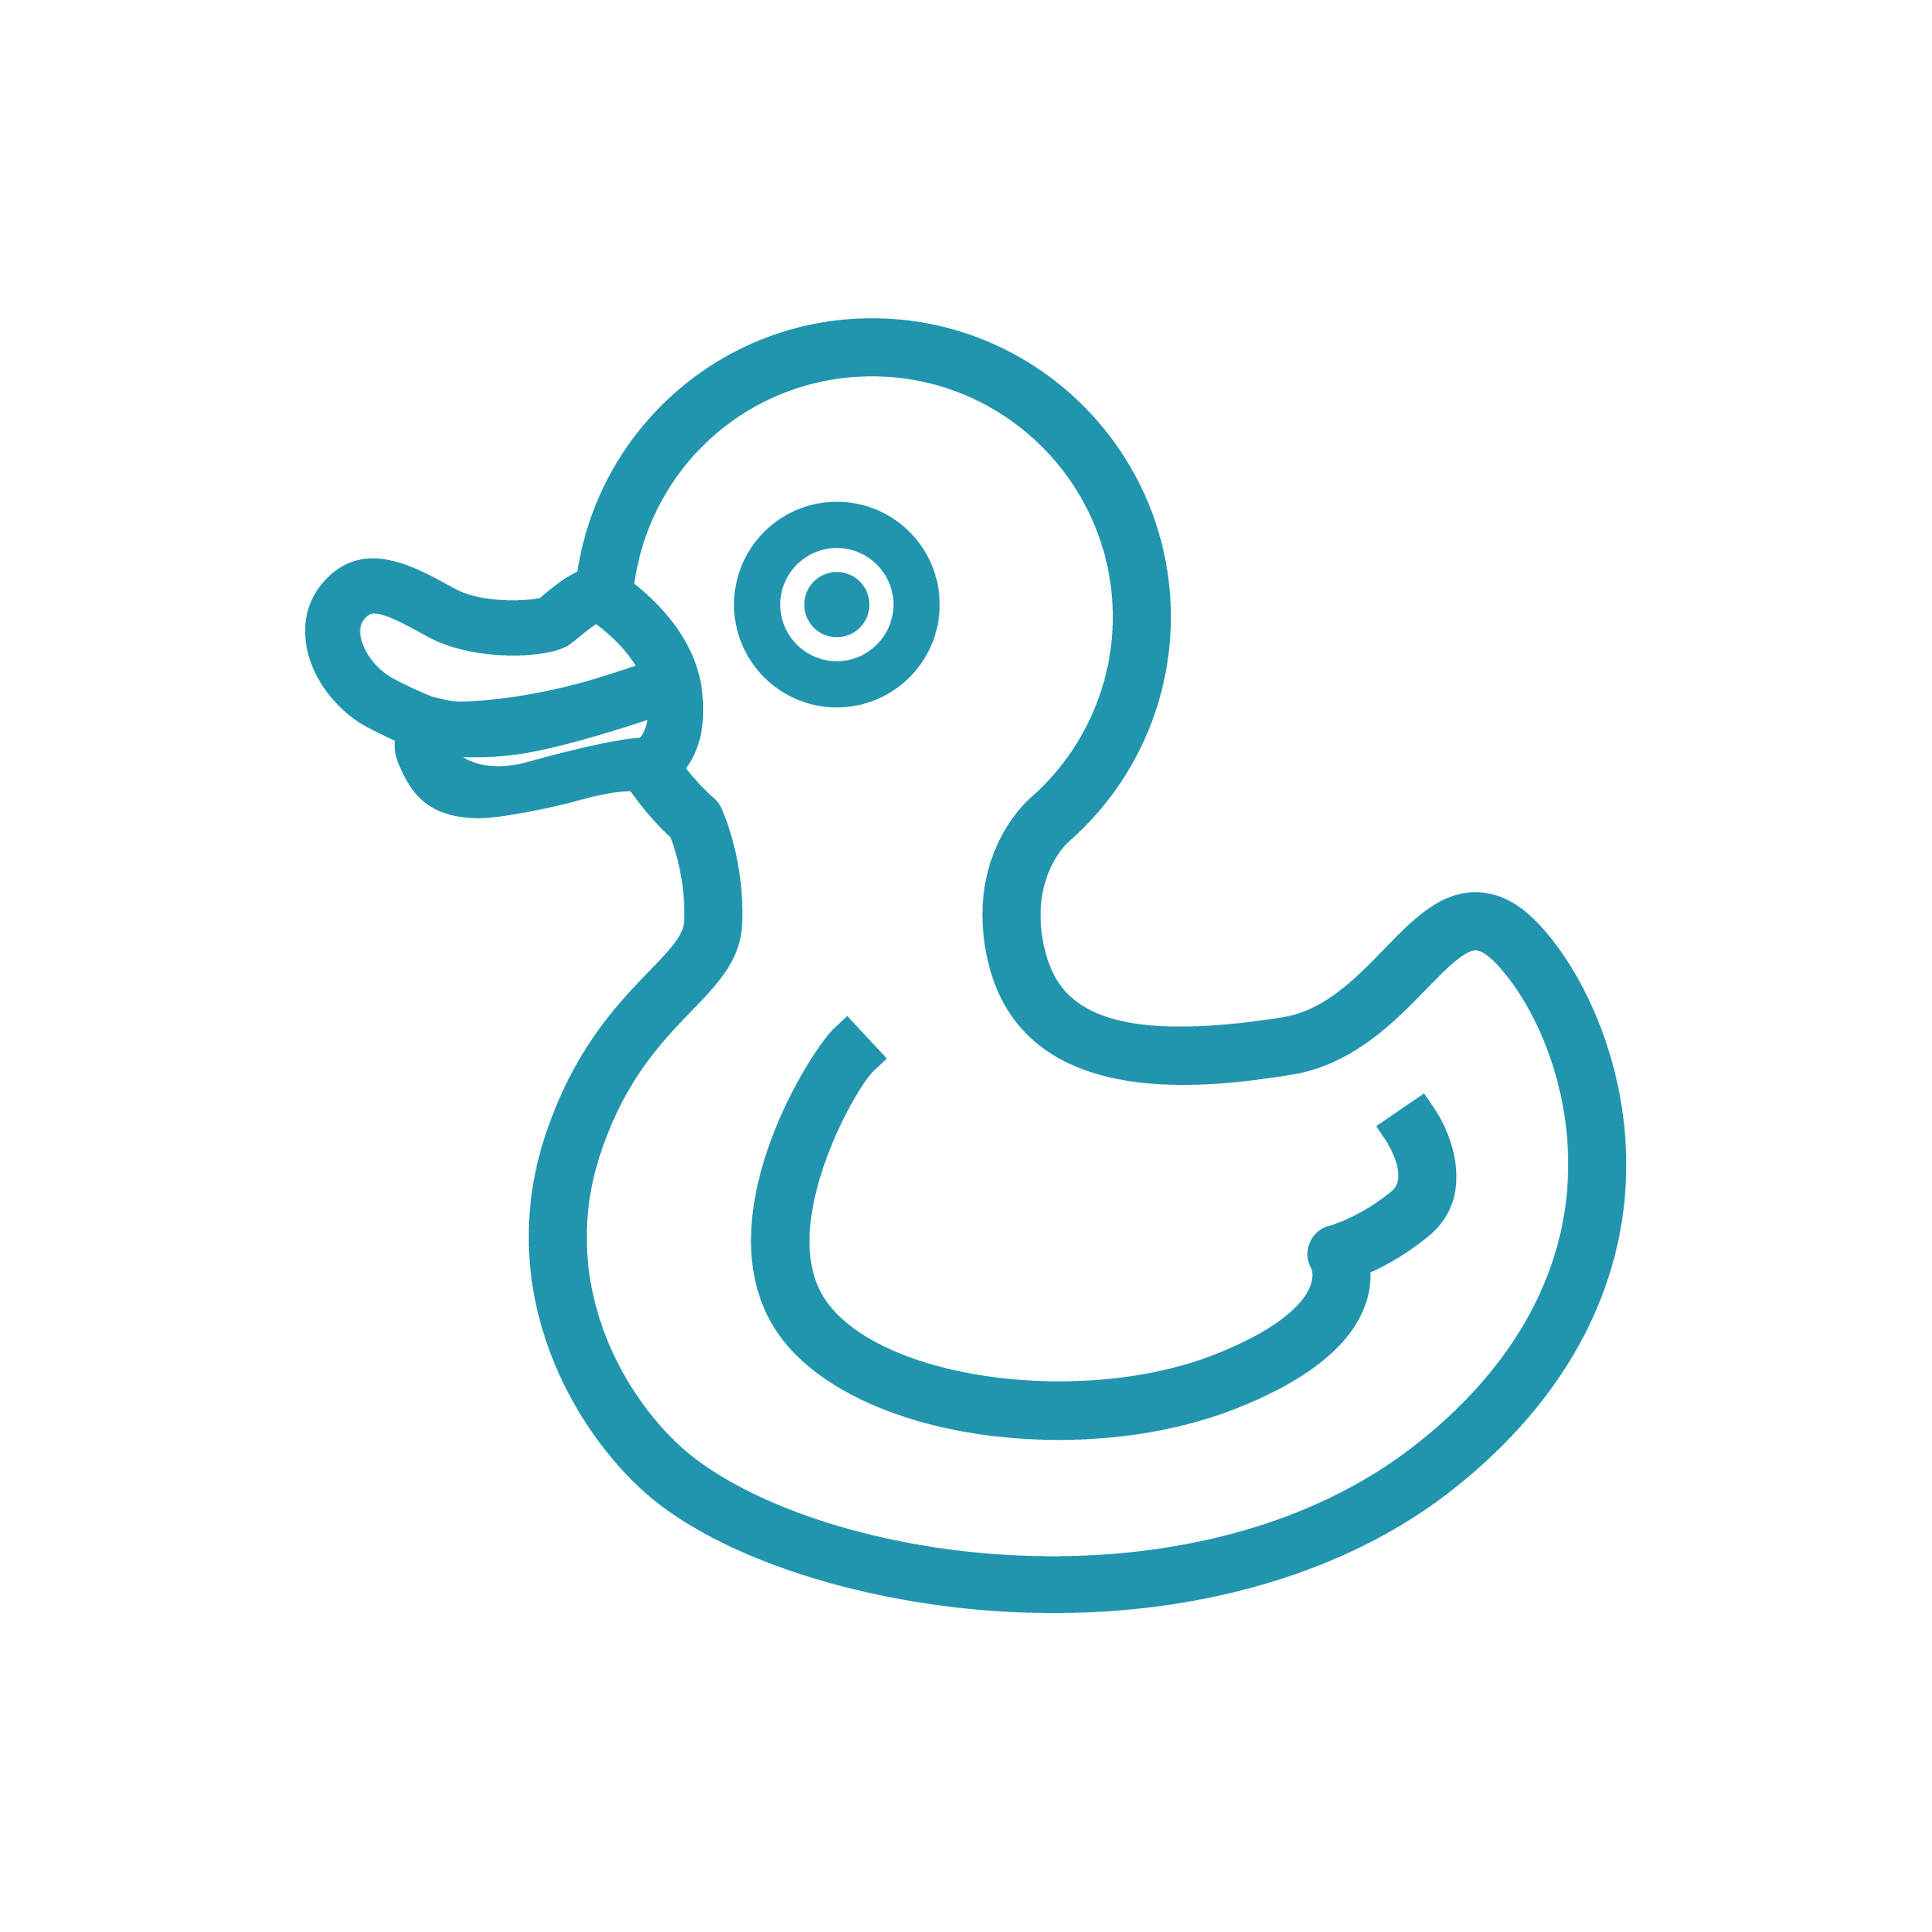







Job Description