**Error! Filename not specified.**

**Essential**

* Ability to manage a varied administrative workload to tight deadlines.
* A team player fostering a supportive environment.
* Proven ability to handle data and produce reports.
* Excellent communication skills (written and verbal), with the ability to interact with individuals from all levels of an organisation.
* Experience of producing meeting minutes and agendas with a high level of accuracy.
* Capability of working independently and within a team.
* Consistent delivery of a high standard of work.
* A proactive and flexible approach to work.
* Resilient and able to work under pressure.
* Organised diary management.
* Maintaining a positive outlook during busy periods.

**Desirable**

* Knowledge of Sports Governance and how Sports Boards/Committees operate.
* Knowledge of the aquatics industry.
* Experience of running small projects, conferences or events.

**Values:**

Quality

Purpose

Togetherness

Fun

Resourceful

**Job Purpose:**

To provide administrative and project support to the Operations department and across the organisation. Contributing to the efficiency of the organisation, internal and external stakeholders (including the Pool Water Treatment Advisory Group), and the overall aquatics community.



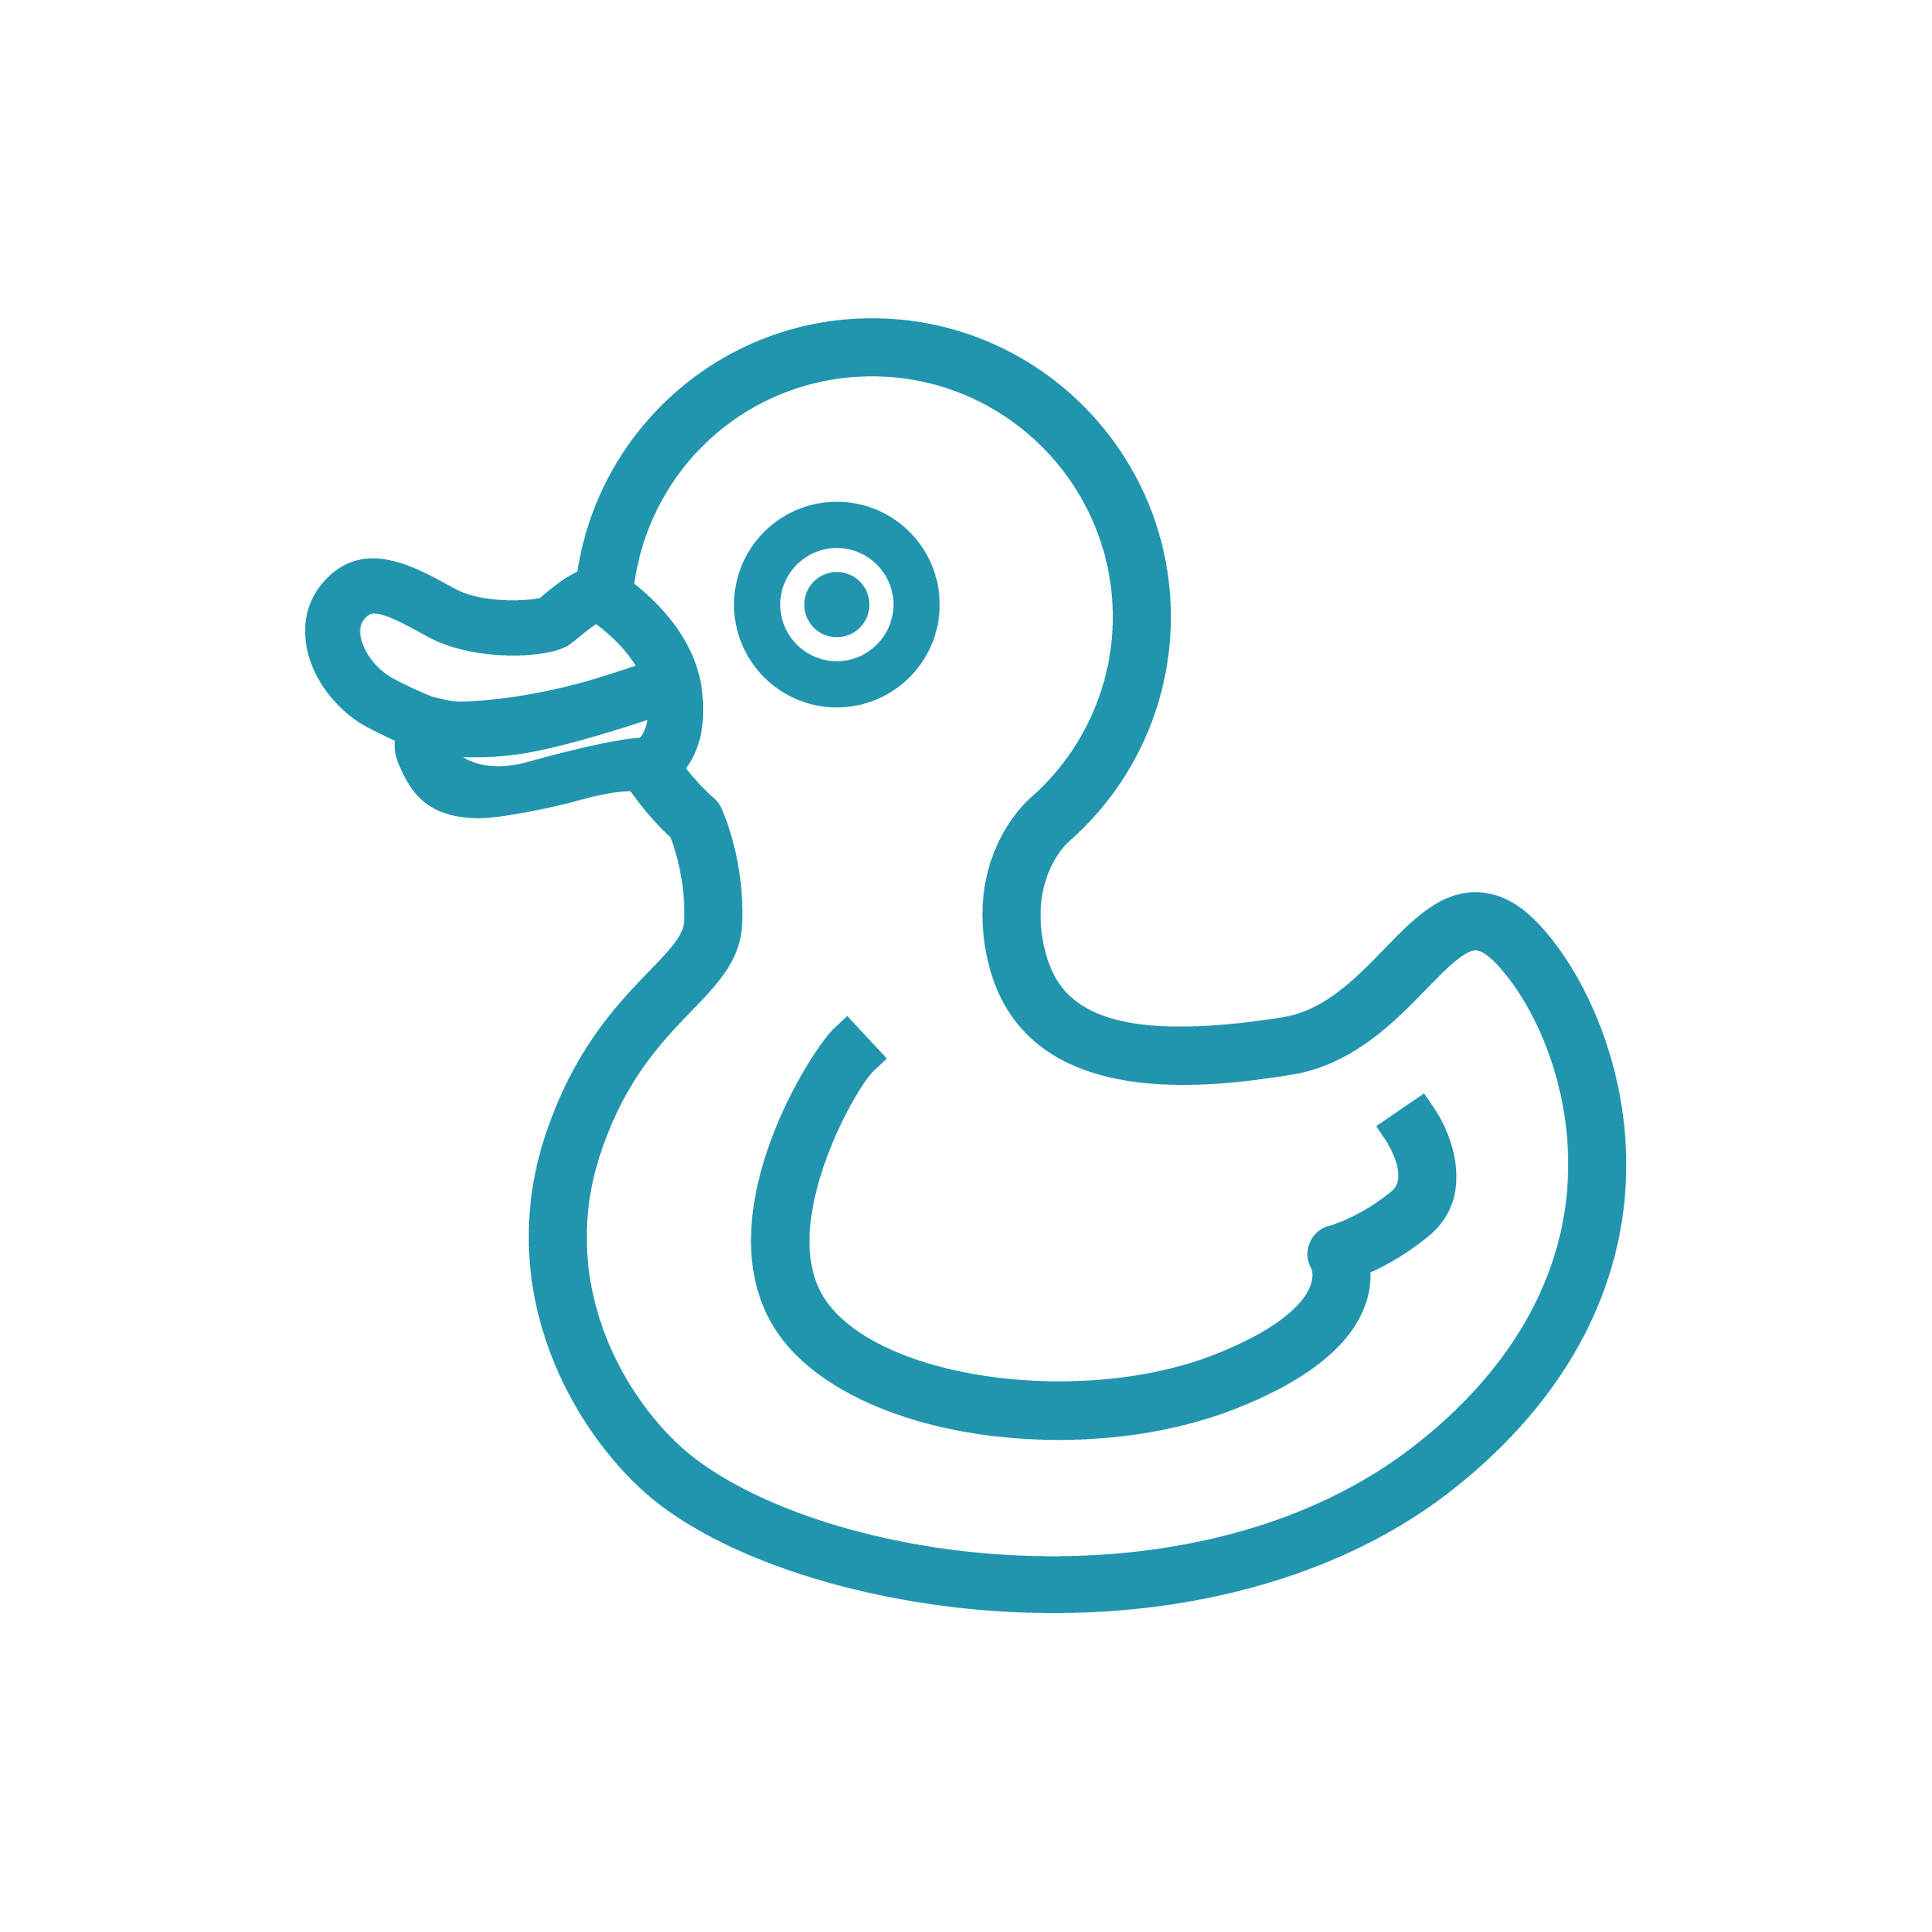







**Job Title:** **Senior Administration Officer**

**Department:** Operations

**Reporting to:** Executive Operations Manager

**Direct Reports:** N/A

**Location:** SportPark (minimum 3 days per week)

**Grade:** 8

**Skills and experience required**

**Key responsibilities**

* Develop and maintain good working relationships with internal team members and external stakeholders.
* Assisting Board and committee members to function effectively by providing first class administrative services and support through the delivery and organisation of meetings, and producing quality minutes.
* Administer the production of the Swim England Handbook.
* Assist in the delivery of the Swim England AGM.
* Oversee administrative support in relation to the Swim England insurance renewal process and ongoing internal enquiries.
* Support administration provision for the Pool and Water Treatment Advisory Group (PWTAG), including monthly reporting, organisation and delivery of conferences, webinars and trade show attendance.
* Working collaboratively to update the PWTAG website as required, and develop content for e-newsletters and social media.
* Organise and attend Council, Forum and AGM meetings, including scheduling, drafting agendas and producing minutes for PWTAG.
* Supporting the Executive Operations Manager regarding budget management for Boards and Committees when required.
* Responding in a timely manner to internal and external queries across multiple email inboxes.
* Provide administrative support and organisation for the CEO and additional projects as delegated by the Executive Operations Manager.

Job Description