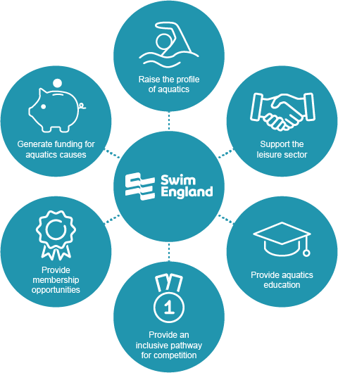
Our Purpose and Vision

As the recognised national governing body for swimming, artistic swimming, diving and water polo in England, Swim England helps people learn how to swim, enjoy the water safely, and compete in all our sports.

Our Vision is to champion a healthy and successful nation through swimming and aquatic activity. The ability to swim is a life-skill that is essential to keep us safe in, on and around water. It is one of the nation’s most popular recreational activities enjoyed by millions of people in England. Swim England, through aquatics, is uniquely placed to tackle inequalities and support health and wellbeing given the activities’ accessibility to people of all ages and abilities. On top of this, aquatics is made up of four amazing Olympic and Paralympic sports with our network of clubs and talent pathways supporting people to realise their full potential in the water.

Our income

Swim England is an incorporated company with charitable status. Our subsidiary businesses (Swim England Trading Limited and Institute of Swimming Limited) are wholly-owned companies which are commercial – whose profits are passed up to Swim England for investment into our charitable aims.

Our income is around £14m (last audited accounts) with around 20 per cent from membership income, 20 per cent from Sport England funding and the balance of 60 per cent from our commercial activities, grants and sponsorships.

What we do
Each month, millions of people are able to enjoy aquatic sports and activities because they have been through our renowned Swim England Learn to Swim Programme. We own the framework that underpins the programme and provide resources to leisure providers, teachers and parents. The framework starts at preschool and continues into adult swimming. Our Awards scheme is the largest in sport with approximately two million awards sold each year.
Swim England is a membership organisation dedicated to supporting more than 950 clubs and more than 175,687 members to develop and succeed. We maintain the laws of the sport and run world-class national events that are open to all competing members across our aquatic disciplines.

Our Learn to Swim Programme and our membership offers, together with our events and talent pathways provide participants with one aquatic pathway from learn to swim to Gold medals.
Ensuring that people are safe in the water is of significant importance to us and so we work closely with partners to keep water safety high on the national agenda. Learning to swim forms part of the national curriculum, and for some children, primary school will be the only opportunity they have to learn these vital life skills. We ensure all our primary schools are supported to provide the best possible swimming and water safety provision for all their pupils.
We also operate a comprehensive range of qualification and education programmes for the wider aquatic workforce, including; teachers, coaches, officials, and tutors. As our Awarding Organisation, Swim England Qualifications provides the professional career pathway for teachers, enabling participants to choose to study their course through our network of Approved Training Centres, across 368 sites.
The Institute of Swimming is a wholly owned subsidiary of Swim England, it is our largest approved training centre and is the leading provider of aquatics courses. Professional Membership with the Institute of Swimming recognises the profession of Swimming Teaching and provides a wide range of benefits such as insurance and legal advice, discounted and free eLearning to enable aquatics educators to keep up to date with all the latest trends via online CPD’s.
We use our unique position to perform valuable research that helps to understand the challenges affecting the landscape, and use our voice to lobby for investment and raise awareness. We have important and valuable relationships across the sector. We advise leisure operators on a wide range of topics such as; technical facilities management, maximising pool space, and attracting people from diverse ethnic communities to local facilities to name a few. We’re also able to offer consultancy services to those who would like a more tailored and in-depth review of how they can maximise their aquatics provision.

